|  |  |  |  |  |
| --- | --- | --- | --- | --- |
| **Nama** | **: Risky Fauziah** |  | **Mata Kuliah** | **: Praktikum Jaringan Komputer** |
| **NIM** | **: 171011450082** |  | **Tugas** | **: Pertemuan ke-7 (B)** |

**b) Konfigurasi HTTP (Hyper Text Transfer Protocol)**

1. Buat simulasi seperti yang ada di modul.

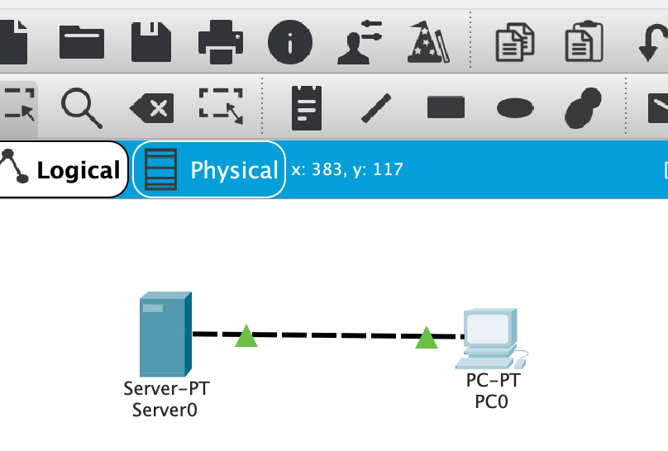

1. Konfigurasi IP address
2. Server0

1. PC0

1. Test koneksi
2. PC0 berhasil terhubung ke Server0:

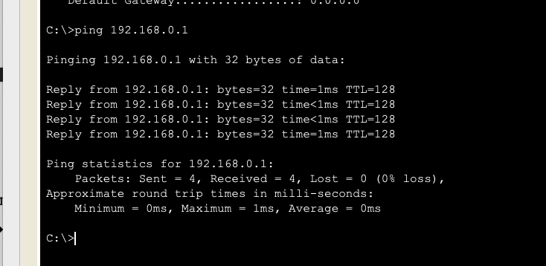

1. Isi file index.html:

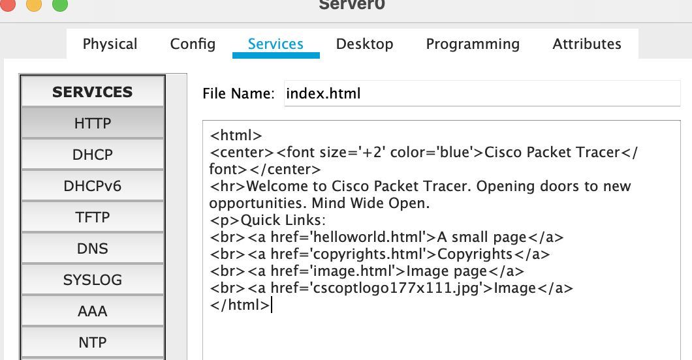

1. e. editing file index.html sesuai modul:

1. Tutup jendela server0.
2. Test halaman website

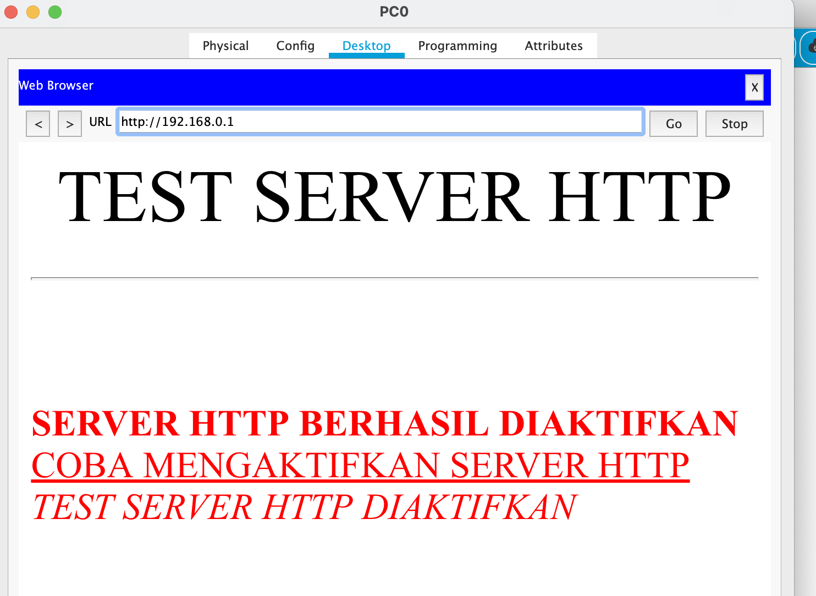

1. Simpan dile dengan nama HTTP.

